# AI Chat-to-Email Automation (n8n Workflow)

## Problem & Target User

Organizations or individuals often receive messages through chat platforms and need to quickly generate intelligent, AI-based responses or summaries — then send those replies via email automatically. This workflow helps automate smart email replies for small teams, freelancers, or businesses who want AI-driven communication without manual typing.

## Tool Chosen

Tool: n8n (AI Agent workflow using Google Gemini + Gmail integration)

Why:  
- Visual no-code automation builder  
- Free self-hosted or cloud tier  
- Integrates easily with Google services (Gmail, Gemini AI)  
- Allows persistent memory and context (Chat Memory + ToolOutput Parser)

## Workflow Summary

1. Trigger: When a chat message is received  
2. AI Agent: Uses Google Gemini Model to understand or generate a reply  
3. Memory: Stores previous context for better responses  
4. Gmail Node: Automatically sends the generated message as an email reply  
  
This creates a simple Chat → AI → Gmail automation loop.

## Cost (PKR)

|  |  |  |
| --- | --- | --- |
| Item | Cost | Notes |
| n8n (Self-host / Free Cloud Tier) | PKR 0 | Free |
| Google Gemini API (Free Tier) | PKR 0 | Within limits |
| Gmail API | PKR 0 | Free |
| Total | PKR 0 | No paid tools needed |

## Outcome

An automated AI-powered assistant that:  
- Reads chat messages  
- Generates smart responses using Google Gemini  
- Sends them via Gmail instantly  
- Costs ₨0 to operate using free-tier tools

**Workflow**

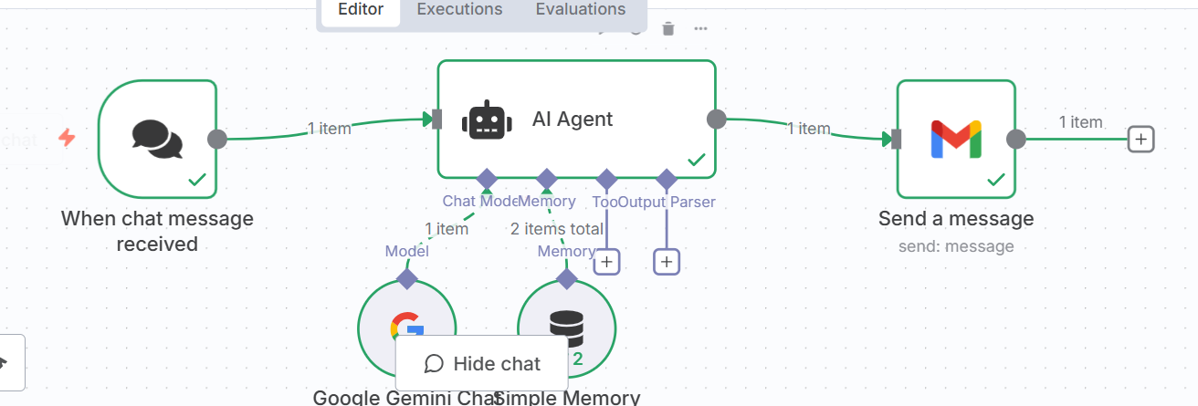

**Video link**

**https://youtu.be/q1hBV-rvENk**